Avian Point Count Report for Indreland Audubon Wetland Preserve 2022

1st Annual Progress Report 2022

Victoria Ann Saab1

1Sacajawea Audubon Society Board Member & Scientist Emeritus USDA Rocky Mountain Research Station

January 2023

**Introduction**

Avian point count surveys were established in spring 2022 to provide baseline information on avian species richness, species abundance, and species diversity at the Indreland Audubon Wetland Preserve (IAWP) managed/owned by Sacajawea Audubon Society (SAS) in Bozeman, Montana. Point count data are being collected to provide a standardized and repeatable method for evaluating changes in avian metrics related to proposed wetland restoration activities and the potential designation of a wetland mitigation bank. The IAWP is being considered by the U.S. Army Corps of Engineers (COE) for the establishment of the Sacajawea Wetland Bank (Bank). Bird point count monitoring for at least a 5-year period is one requirement by the COE for designation of the wetland mitigation bank. The Bank will be used to mitigate for unavoidable wetland impacts approved through the COE (administered by Section 404 of the Clean Water Act). The Bank will provide a local wetland mitigation option to help offset wetland impacts occurring specifically in Bozeman and the surrounding watershed. Monitoring may be extended if success of performance standards (increases in species richness, abundance, and diversity) is not achieved within the five-year period. The performance standards for birds as defined by Confluence Consulting (2022) include the following:

a. Avian species richness (i.e., number of species identified) within vegetated wetland and open water areas will exhibit a 10% increase over baseline conditions (63 species) by the final monitoring year.

b. Avian species abundance will increase by 10% over baseline conditions by the final monitoring year.

c. Avian species diversity, using the Shannon-Wiener Diversity Index will increase by the final monitoring year.

**Study Area**

The IAWP is located on the east side of Bozeman, Montana in Gallatin County (Latitude 45.681688°, Longitude -111.013765°) north of the I-90/Main St. interchange (Figure 1). The site consists of two parcels, located north and south of the railroad tracks, comprising 6.8 acres and 31.2 acres, respectively. Montana Rail Link (MRL) operates the railroad tracks, which bisect the project area northwest to southeast and separates the two parcels. A 30-ft tall historic railroad berm divides the 31.2-acre south parcel into two areas, located northwest and southeast of the berm, respectively. The Montana Department of Transportation's (MDT) I-90 East Bozeman Wetland Mitigation Reserve is located immediately southeast of the project's southern parcel.

**Methods**

We established 9 point-count locations within the IAWP (Figure 2) to provide a representative sampling of the potential wetland mitigation bank. Point count stations were located in proportion to the area of various habitats. All birds seen or heard were recorded during a 5-min point count survey within a 75-m radius of each point count location. Point counts were located a minimum of 150 meters apart to maintain independence of counts between locations.

Surveys were conducted every two weeks from mid-April through late-October to collect data during spring migration, breeding season and fall migration. All surveys were recorded by one person, not by pairs or groups, to maintain consistency and comparability of the data among years. Data were not collected during inclement weather, including strong winds and rain.

Six observers conducted point counts during 2022 (Table 1). Each person conducted 1-3 surveys. We recorded data on field forms and subsequently entered data into eBird (<https://science.ebird.org/en/use-ebird-data/citation>; Sullivan et al. 2009). We did not correct for imperfect species detectability among observers (MacKenzie et al. 2009).

We report avian species richness (total number of species), species abundance (total number of individuals counted per species) and species diversity. We derived the Shannon-Weiner Species Diversity Index (H’), which is calculated by taking the number of each species, the proportion each species is of the total number of individuals, and then sum the proportion times the natural log of the proportion for each species (Nolan and Callahan 2006).

**Results/Discussion**

Sixty-seven bird species (species richness) and 1,908 individuals (species abundance) were recorded during 15 point-count surveys in 2022 (Table 2 and Appendix 1). The Shannon-Weiner Species Diversity Index (H’) was 3.2 (Appendix 1). These data provide the baseline information needed to evaluate the success of performance standards for species richness, abundance, and diversity over the next five years.

The most abundant species was Red-winged Blackbird (total of 357 individuals), whereas Trumpeter Swan, Mourning Dove, Calliope Hummingbird and Great Blue Heron were each recorded once only. Two nests of American Coot were located during point counts and breeding activity was noted for species with juveniles (hatch year birds) and those feeding young.

To improve efficiency and reduce recording errors, we will collect data using eBird on our smart phones starting next year (2023). We will have training for observers prior to the field season.

**Acknowledgments**

Paulette Epple, John Parker, Rich McEldowney and John Edwards assisted with the initial set-up of point count locations.  Rich McEldowney of Confluence Consulting Inc. [CCI] created the maps of the study area and point count locations. CCI employees placed permanent rebar posts at point count centers.  Victoria Saab, John Parker, and Oakley Strauss assisted with training observers to conduct point count surveys and with eBird data entry. We are grateful to all observers that conducted point count surveys (see Table 1).

**Literature Cited**

Confluence Consulting Inc. 2022. Sacajawea Wetland Bank Instrument DRAFT. *Gallatin County Montana*. *Prepared by* **Confluence Consulting Inc.** 1115 North 7th Ave, Suite 1, Bozeman, Montana 59771. CCI Project No. SAS.001.02. February 2022. 80 pp.

Nolan, K.A. and J.E. Callahan. 2006. Beachcomber biology: The Shannon-Weiner Species Diversity Index. Pages 334-338, *in* Tested Studies for Laboratory Teaching, Volume 27 (M.A. O'Donnell, Editor). Proceedings of the 27th Workshop/Conference of the Association for Biology Laboratory Education (ABLE), 383 pages.

MacKenzie, D. I., Nichols, J. D., Seamans, M. E., & Gutiérrez, R. J. 2009. Modeling species occurrence dynamics with multiple states and imperfect detection. *Ecology* 90: 823-835.

Sullivan, B.L., C.L. Wood, M.J. Iliff, R.E. Bonney, D. Fink, and S. Kelling. 2009. eBird: a citizen-based bird observation network in the biological sciences. *Biological Conservation* 142: 2282-2292.

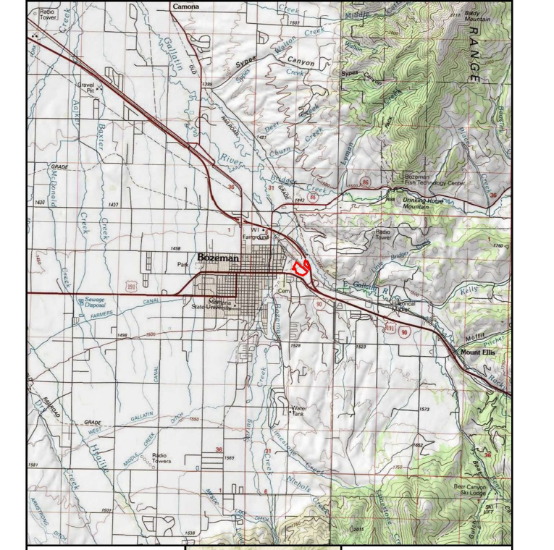

Figure 1. Location of Indreland Audubon Wetland Preserve outlined in red **-----.**

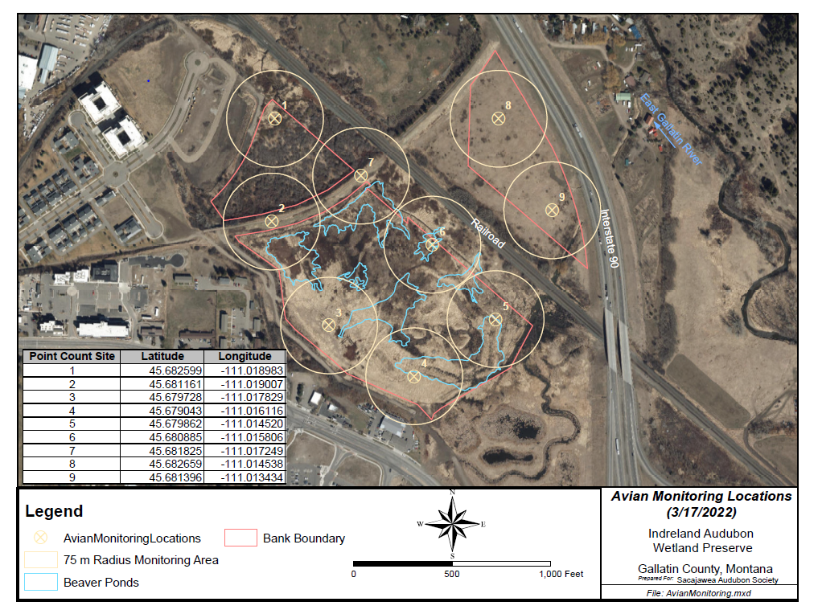

Figure 2. Point Count (Avian Monitoring) locations  at IAWP.

Table 1. Avian point count surveyors by date during 2022.



Table 2. Species richness (total number of species = 67) and species abundance (total count of individuals = 1,908) recorded during 5-minute point count surveys conducted twice per month (3x in Oct) from April through October 2022 on the Indreland Audubon Wetland Preserve.

|  |  |  |  |  |  |  |  |
| --- | --- | --- | --- | --- | --- | --- | --- |
| **Species** | **15 & 27 Apr** | **11 & 26 May** | **8 & 22 Jun** | **8 & 20 Jul** | **3 & 17 Aug** | **2 &14 Sep** | **2, 12, & 30 Oct** |
| Canada Goose | 8 | 12 | 2 |  |  |  |  |
| Trumpeter Swan |  |  |  | 1 |  |  |  |
| Wood Duck |  |  |  | 1 |  | 1 |  |
| Cinnamon Teal |  |  | 3 |  | 1 |  |  |
| Gadwall |  |  |  |  | 4 |  | 1 |
| American Wigeon |  |  | 3 |  | 1 |  |  |
| Mallard | 20 | 23 | 23 | 29 | 42 | 29 | 51 |
| Green-winged Teal | 3 |  | 2 |  |  | 4 |  |
| Ruddy Duck |  |  |  | 2 |  | 1 |  |
| Ring-necked Pheasant | 3 |  |  |  |  |  | 1 |
| Eurasian Collared-Dove |  |  | 1 | 1 | 1 |  |  |
| Mourning Dove |  |  |  |  | 1 |  |  |
| Calliope Hummingbird |  |  | 1 |  |  |  |  |
| Sora | 1 | 1 |  | 1 |  |  |  |
| American Coot | 6 | 9 | 6 | 14 | 5 | 15 | 8 |
| Sandhill Crane |  |  |  | 2 | 4 |  |  |
| Black-necked Stilt |  |  | 9 |  |  |  |  |
| Killdeer |  | 2 | 1 | 1 | 3 |  |  |
| Wilson's Snipe | 9 | 6 | 2 | 3 |  | 1 |  |
| Great Blue Heron |  |  |  |  | 1 |  |  |
| Northern Harrier | 2 |  |  |  |  |  |  |
| Red-tailed Hawk |  |  |  |  |  |  | 6 |
| Belted Kingfisher |  |  | 2 | 1 |  |  |  |
| Downy Woodpecker | 2 |  |  |  |  |  | 2 |
| Northern Flicker | 2 |  | 1 | 1 | 1 |  | 2 |
| Olive-sided Flycatcher |  |  |  |  |  | 2 |  |
| Willow Flycatcher |  |  | 4 | 1 | 2 |  |  |
| Least Flycatcher |  |  |  |  | 3 |  |  |
| Eastern Kingbird |  |  | 2 | 1 | 7 | 1 |  |
| Warbling Vireo |  |  | 2 |  |  | 1 |  |
| Black-billed Magpie | 13 | 11 | 8 | 4 | 6 | 3 | 15 |
| American Crow | 2 |  |  | 3 |  | 1 | 7 |
| Common Raven |  |  | 2 |  | 1 |  |  |
| Black-capped Chickadee | 26 | 12 | 2 | 2 | 11 | 5 | 43 |
| Northern Rough-winged Swallow |  |  |  | 4 |  |  |  |
| Tree Swallow |  | 6 | 8 | 13 | 4 |  |  |
| House Wren |  |  |  | 2 | 5 |  | 1 |
| **Species *(Table 1 cont.’ p. 2)*** | **Apr** | **May** | **Jun** | **Jul** | **Aug** | **Sep** | **Oct** |
| Marsh Wren | 1 | 5 | 13 | 10 |  |  | 2 |
| European Starling | 5 | 1 | 3 | 4 |  | 70 | 66 |
| Gray Catbird |  | 2 | 5 | 4 | 3 | 12 |  |
| American Robin | 40 | 10 | 17 | 6 | 7 | 5 | 53 |
| Cedar Waxwing |  |  | 33 | 9 | 13 | 12 | 9 |
| House Sparrow | 3 |  | 3 | 1 | 2 |  | 1 |
| House Finch | 10 |  |  | 2 | 11 | 9 | 18 |
| Pine Siskin | 8 | 1 | 9 | 1 | 12 | 10 |  |
| American Goldfinch |  | 5 | 1 | 19 | 22 | 17 | 1 |
| Clay-colored Sparrow |  |  |  |  |  | 2 |  |
| American Tree Sparrow |  |  |  |  |  |  | 10 |
| Dark-eyed Junco |  |  |  |  |  |  | 3 |
| White-crowned Sparrow |  |  |  |  |  | 16 |  |
| Savannah Sparrow |  | 5 | 7 | 1 |  |  |  |
| Song Sparrow | 14 | 8 | 13 | 7 | 1 | 2 | 5 |
| Lincoln's Sparrow |  |  |  |  |  | 8 |  |
| Yellow-headed Blackbird | 4 | 12 | 12 | 19 | 4 |  |  |
| Western Meadowlark |  |  | 5 |  |  |  |  |
| Red-winged Blackbird | 69 | 62 | 44 | 77 | 68 | 6 | 31 |
| Brown-headed Cowbird |  | 3 | 1 | 6 |  |  | 2 |
| Brewer's Blackbird |  |  | 2 | 7 | 3 |  |  |
| Common Grackle |  |  |  |  | 1 |  | 1 |
| Northern Waterthrush |  | 3 |  |  |  |  |  |
| Common Yellowthroat |  | 3 | 6 | 12 | 4 | 6 |  |
| American Redstart |  |  | 1 | 1 |  |  |  |
| Yellow Warbler |  | 8 | 15 | 26 | 25 | 1 |  |
| Yellow-rumped Warbler | 2 | 3 |  |  |  |  |  |
| Wilson's Warbler |  |  |  |  |  | 2 |  |
| Black-headed Grosbeak |  |  | 4 | 2 | 1 |  |  |
| Lazuli Bunting |  |  | 1 |  | 1 |  |  |

Appendix 1. Data summary for calculating the Shannon-Weiner Diversity Index.